**Practical-3**

**DBMS LAB**

**Aim**: Write a student table (roll_no, name, department) and write the queries to alter and update the table:

1. View the created table

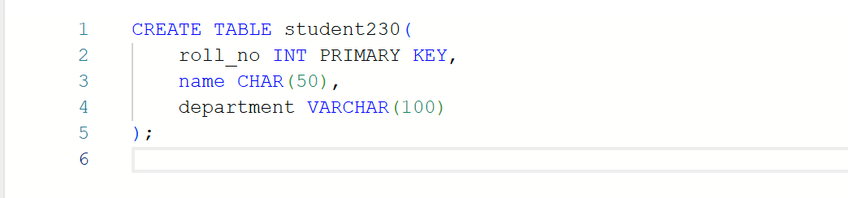

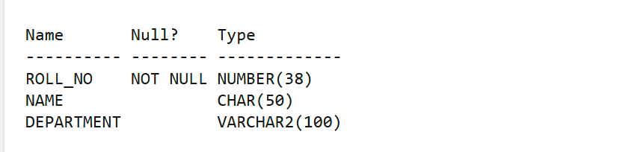

2. Add another column to add phone no.

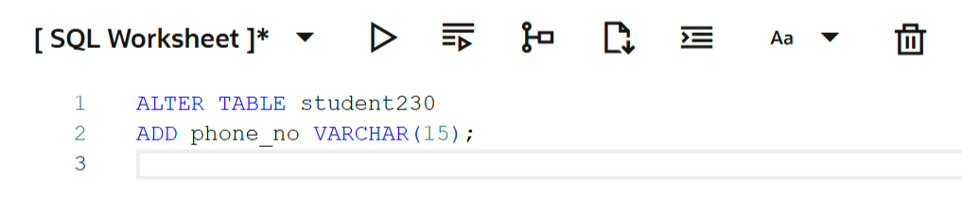

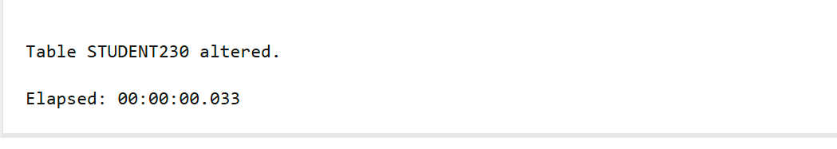

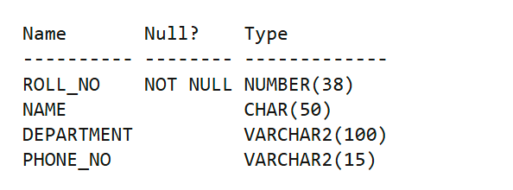

3. Change the datatype of column name

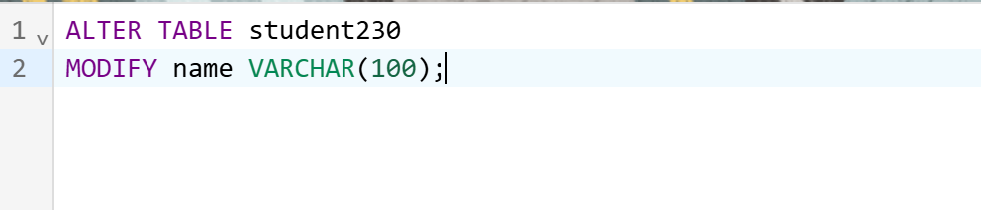

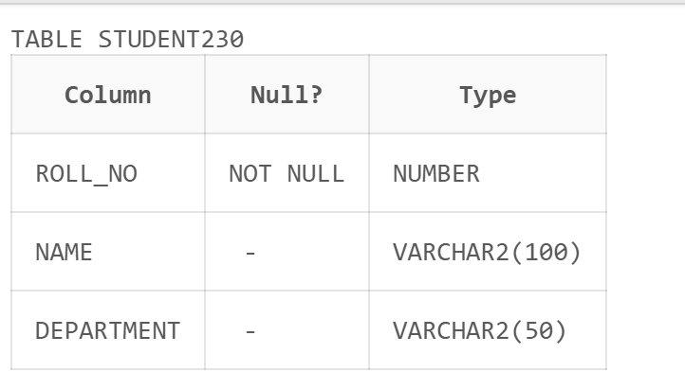

4. Add 10 new records to the table

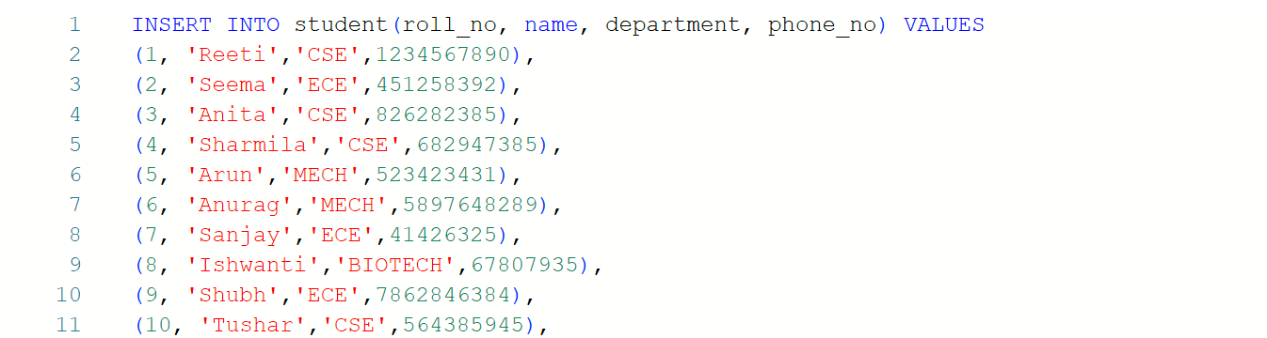

5. Update the department of CSE students to AIML

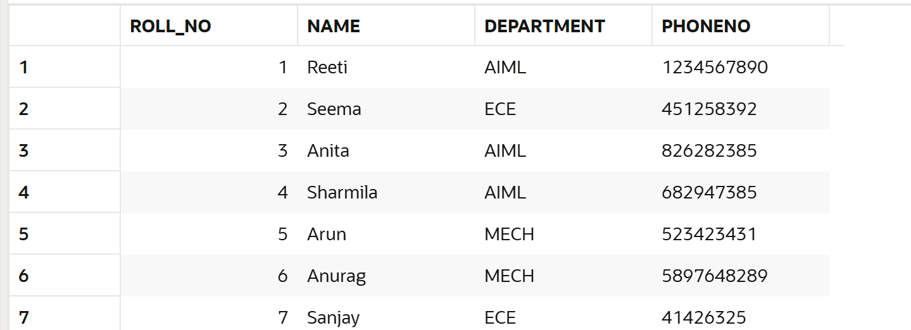

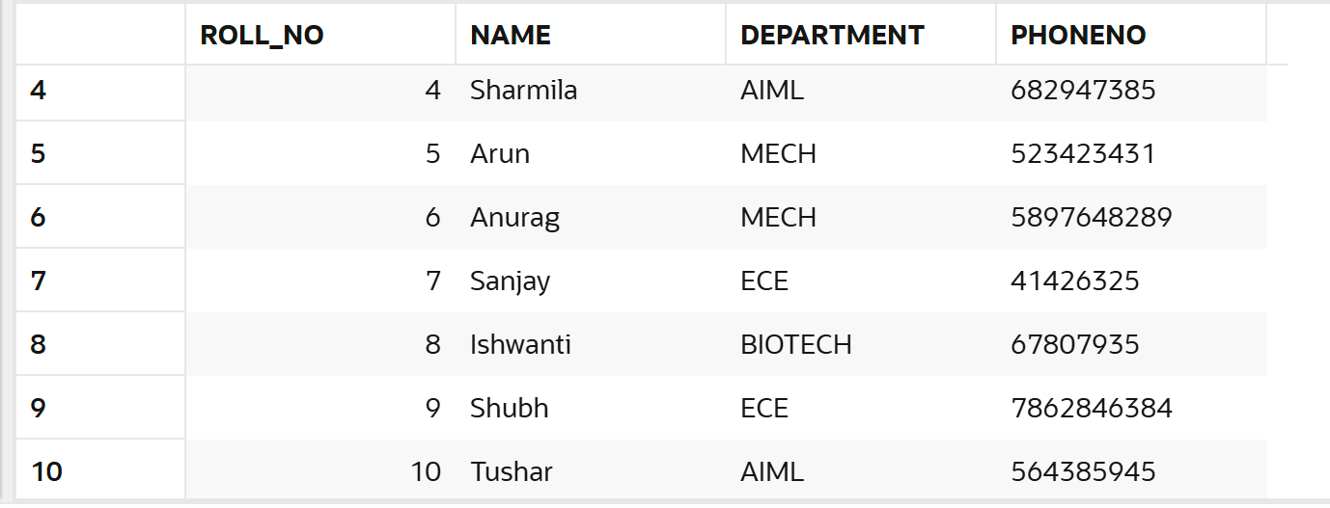

6. Delete column department



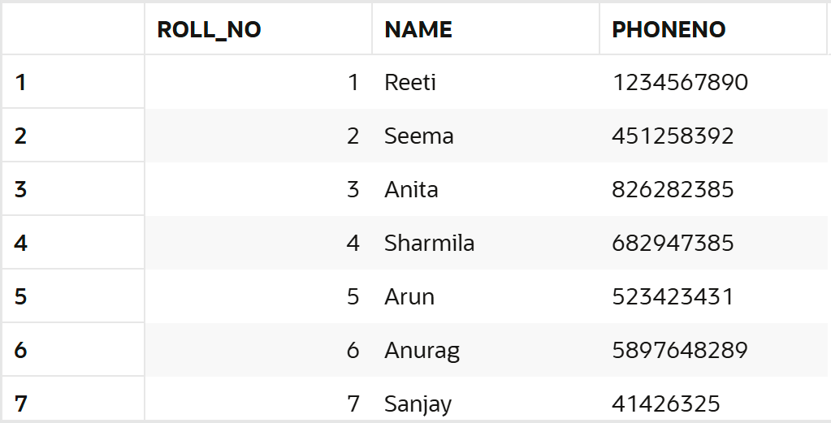

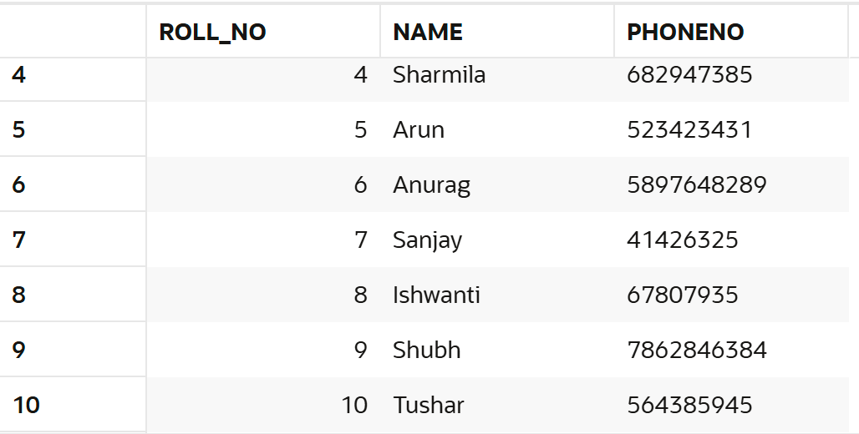

7. Drop table

